AI Day: Computer Vision
AI creates images based on text descriptions called prompts, it is very important for the prompt to be good to create a good image
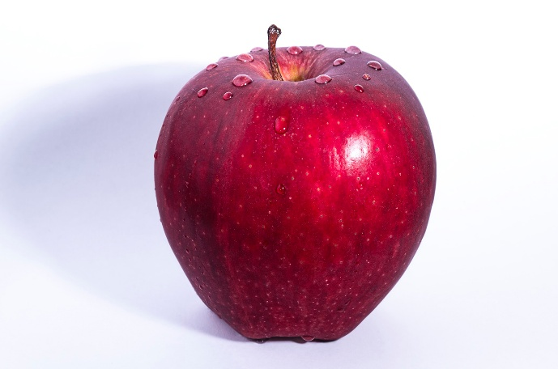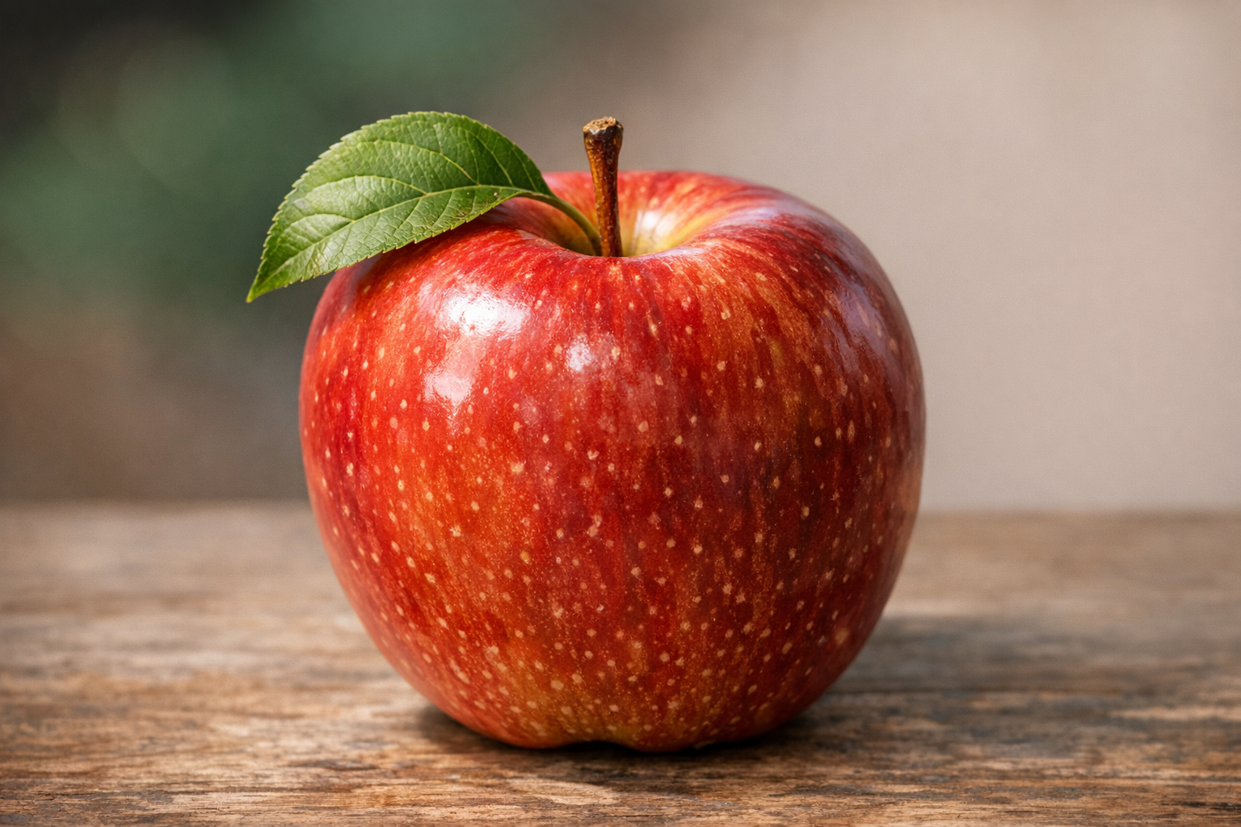
Which one of these two images is real and which one is AI? How can you tell?

AI is trained on millions of images and learns patterns(colors, shapes, objects) and combines them to generate any image.
AI can also analyze images and describe what it “sees”.
AI looks for specific objects, colors and shapes, actions and texts when analyzing a picture.
Classwork: Part 1: Create the following image using AI and try to make it look like it wasn’t AI. “A teenager sitting at their desk in their room, studying with a laptop and notebook open, slightly messy room with books and backpack”
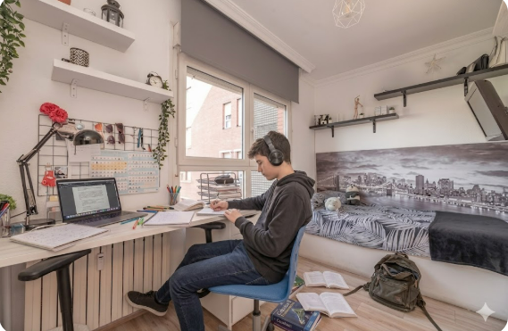
Part 2: Use a reference picture to create the image.
Part 3: Tell the AI to give you a realistic April Fools prank.

